4 Best Yoga Teacher Training Schools in Bali for 2027: Our Recommendations
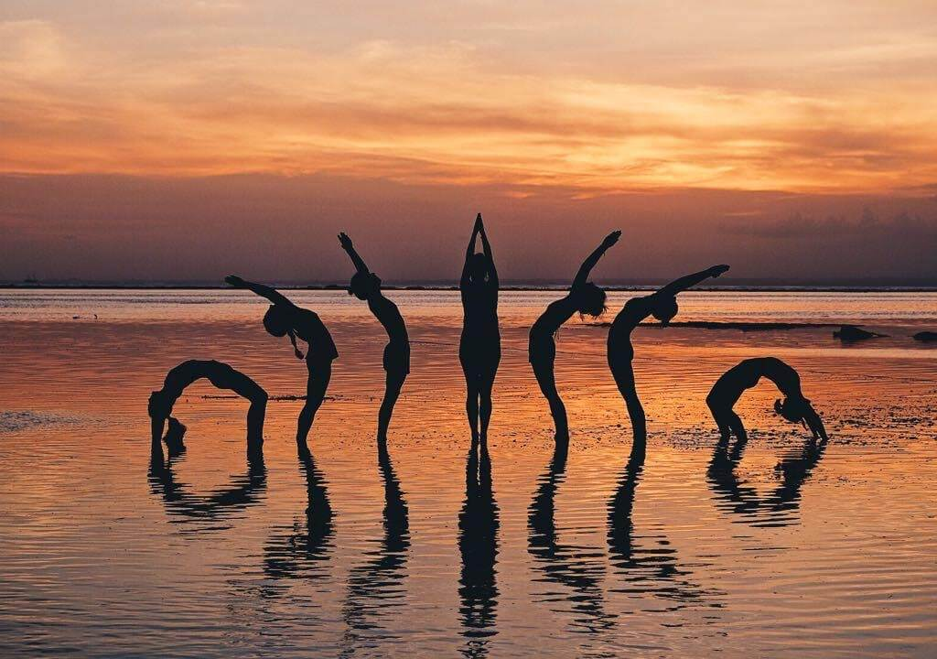
At Adhiroha, we've spent years training aspiring yoga teachers in Rishikesh, India. Through our experience, we've learned that choosing the right yoga teacher training goes beyond certification. Teaching methodology, instructor expertise, hands-on practice and the learning environment all play an important role.
With Bali becoming another popular destination for yoga teacher training, we've drawn on our experience as yoga educators to select four yoga teacher training schools in Bali worth considering for 2027.
Our recommendations are based on each school's curriculum, teaching approach, practical training opportunities and overall learning environment, helping you find a programme that best matches your goals.

Best Yoga Teacher Training Schools in Bali: Quick Comparison

Yoga school | Location | Best suited to | Duration | Advertised starting price
All Yoga Training | Nusa Lembongan | Ashtanga Vinyasa, hands-on teaching and beachfront island training | 23 days | US$3,150
Joga Yoga | Canggu | Multi-style yoga and a lively community | Around 3 weeks | €1,650, excluding accommodation
Power of Now Oasis | Sanur | Hatha, Vinyasa and a relaxed beachfront environment | 27 days | Confirm 2027 rates
Loka Yoga School | Kedungu | Yoga anatomy, biomechanics and functional movement | 28 days | US$2,800, with meals
Prices reflect publicly advertised rates or available school information reviewed in October 2026. Promotional rates, inclusions and accommodation availability may change.
How we selected these schools: Drawing on our experience in yoga teacher education, we compared publicly available programme information, including teaching styles, course structure, practical training, instructor support, location and published student feedback. Our recommendations reflect the different needs of aspiring yoga teachers, rather than a single ranking based on price or popularity.

1. All Yoga Training – Best for Ashtanga Vinyasa and Practical Teaching Experience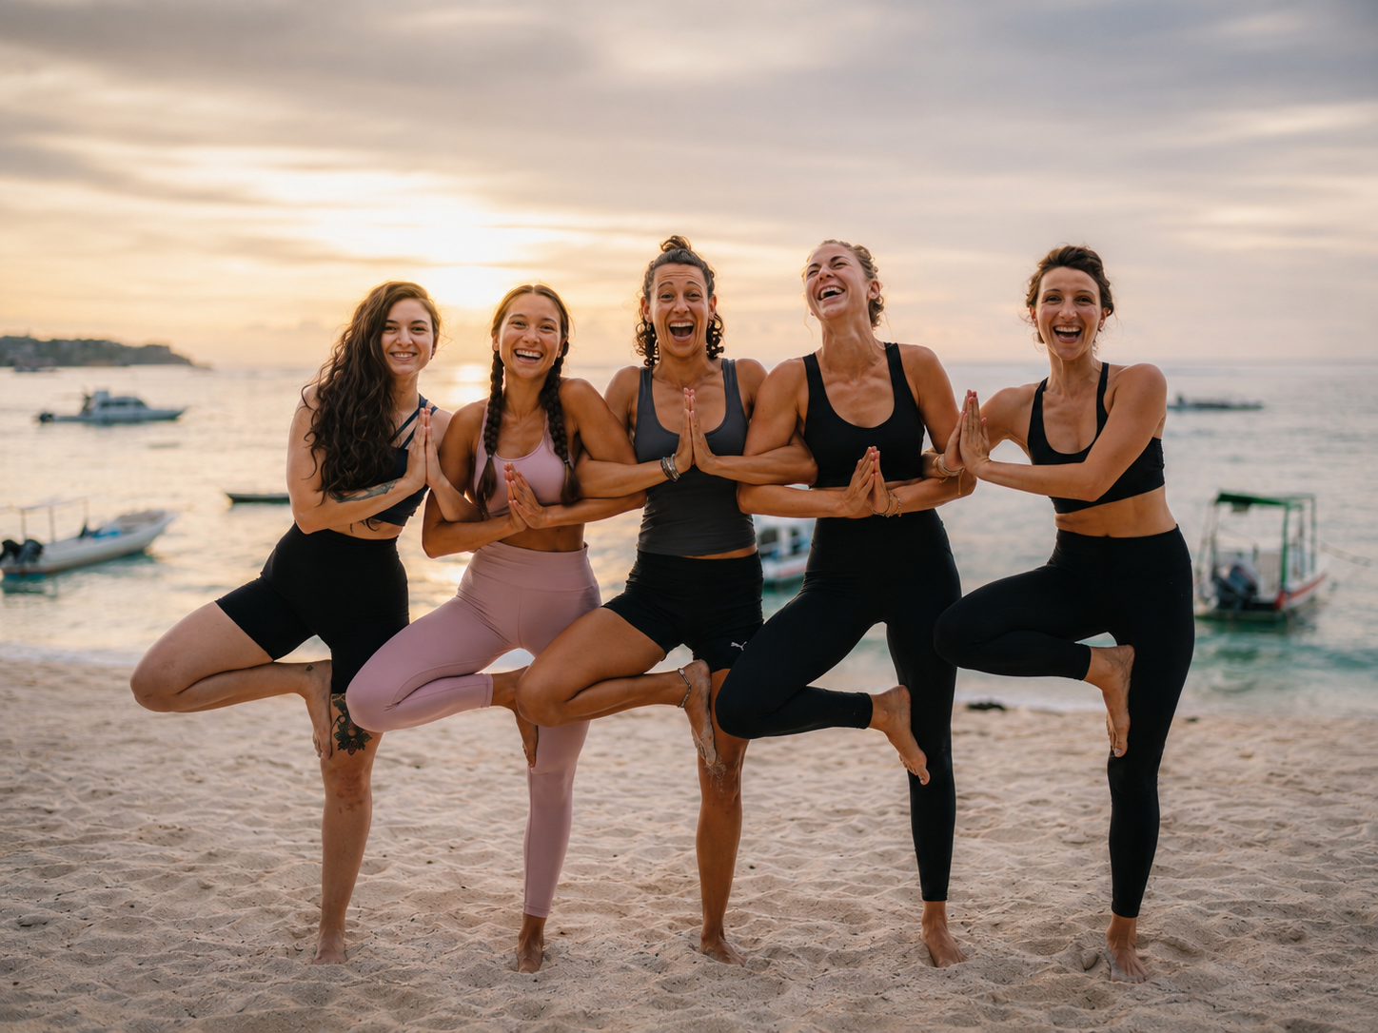

Location: Nusa Lembongan, Bali

Best for: Aspiring yoga teachers who want an Ashtanga-based foundation, practical teaching experience from the beginning of their course and immersive beachfront training.

Established in 2009, All Yoga Training is a Yoga Alliance Registered Yoga School offering a 23-day, 200-hour yoga teacher training programme on Nusa Lembongan, an island southeast of mainland Bali.

The school focuses on Ashtanga Vinyasa Yoga while incorporating Rocket Yoga, Creative Vinyasa Flow, Yin Yoga and Mysore-style self-practice.

What makes All Yoga Training stand out?

One of the school's main differentiators is its teach-from-day-one approach.

Rather than leaving teaching experience until the final stage of training, students begin developing their teaching skills from the outset. Practical sessions focus on verbal cueing, sequencing, alignment, adjustments, class planning and guiding fellow students through yoga postures.

This makes All Yoga Training particularly relevant for students whose main goal is to become confident instructors, rather than simply deepen their personal asana practice.

The programme also covers anatomy, yoga philosophy, pranayama, meditation and traditional Ashtanga methodology. Students develop their own practice while learning how to communicate that knowledge to others.

According to the school, All Yoga Training has welcomed more than 3,500 graduates since 2009 and has accumulated over 300 five-star Google reviews. Training groups are capped at 24 students, allowing for individual guidance and feedback during the intensive programme.

Another attraction is the setting. Classes take place in a beachfront yoga shala on Nusa Lembongan, where students can combine structured daily training with the quieter pace of island life.

2027 programme details

Main styles: Ashtanga Vinyasa, Rocket Yoga, Creative Vinyasa Flow, Yin Yoga

Duration: 23 days

Group size: Maximum 24 students

Certification: 200-hour certificate from a Yoga Alliance Registered Yoga School

Price: From US$3,150 for selected 2027 intakes

Accommodation: Free accommodation advertised for the first 10 sign-ups on qualifying intakes; conditions apply

Who should choose All Yoga Training?

All Yoga Training is one of the strongest fits in this shortlist for students seeking an intensive Ashtanga Vinyasa yoga teacher training in Bali with an early emphasis on practical teaching. Its combination of structured methodology, an established graduate community, small-group learning and beachfront location makes it especially relevant to future instructors who want experience leading classes before graduation.

Students who prefer a predominantly restorative course or a slower-paced retreat should consider whether its physically demanding Ashtanga-based schedule is right for them.

Explore the 200-hour yoga teacher training in Bali to review course dates, curriculum, prices and accommodation offers for 2027.

2. Joga Yoga – Best for Multi-Style Training in Canggu
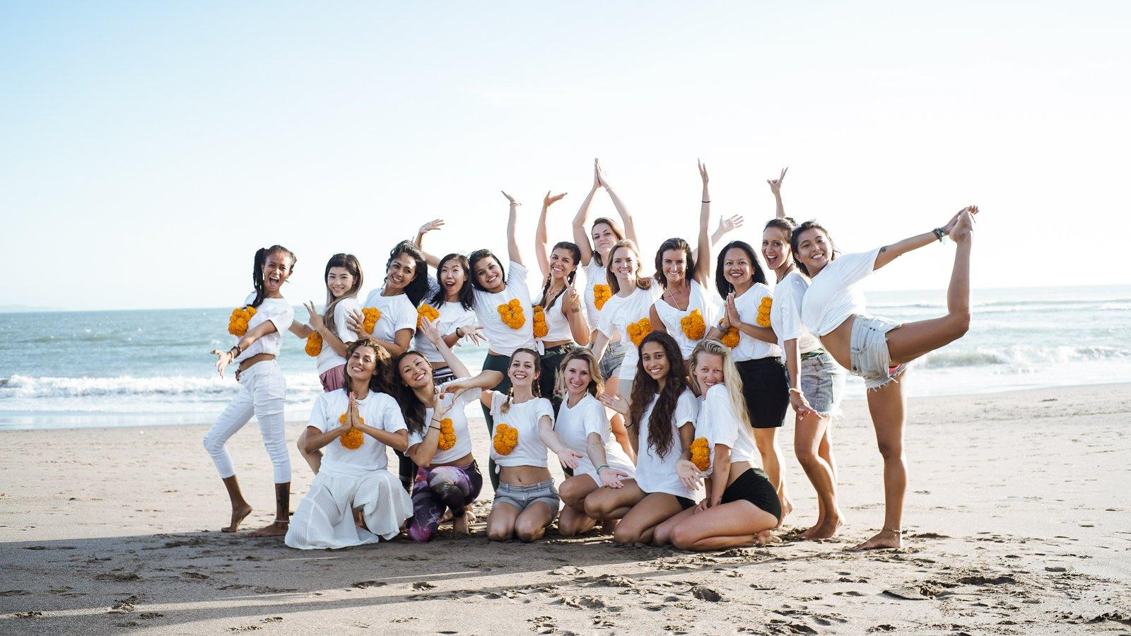

Location: Canggu, Bali

Best for: Students who want to explore several yoga styles while enjoying Canggu's international wellness community.

Joga Yoga offers a 200-hour teacher training programme combining Hatha, Vinyasa, introductory Ashtanga Vinyasa and Yin or restorative practices.

Rather than concentrating on a single yoga tradition, the course introduces students to several approaches to movement, breathwork and teaching.

The curriculum covers anatomy, physiology, yoga philosophy, meditation, sequencing and practical teaching methodology. The school also advertises small cohorts of approximately 10–16 students.

Its Canggu location appeals to trainees who enjoy cafés, surfing, wellness studios and social activities outside training hours.

Programme details

Styles: Hatha Vinyasa, Creative Vinyasa, introductory Ashtanga and Yin

Duration: Approximately three weeks

Certification: 200-hour training through a Yoga Alliance Registered Yoga School

Price: From €1,650 for the non-accommodation package

Accommodation: Separate dormitory and private-room packages are available

Who should choose Joga Yoga?

Joga Yoga is worth considering for trainees who prefer a broad introduction to different yoga styles and want to remain close to Canggu's active social scene.

Students looking for a more secluded island experience may prefer a different location.

3. Power of Now Oasis – Best for Hatha and Vinyasa in Sanur
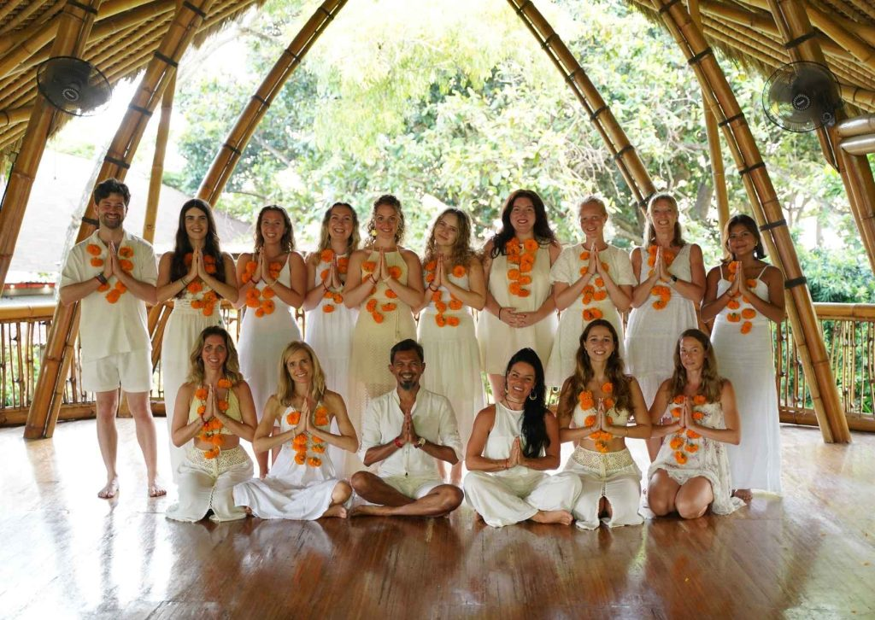

Location: Sanur, Bali

Best for: Students seeking a Hatha and Vinyasa foundation in a relaxed beachfront environment.

Power of Now Oasis has offered yoga programmes in Sanur since 2010 and runs a 200-hour teacher training course over approximately four weeks.

The school teaches Hatha and Vinyasa yoga, with supporting study in anatomy, philosophy, meditation, teaching methodology and Ayurveda.

Training takes place in a distinctive bamboo yoga shala by the beach. Sanur offers a different atmosphere from Canggu, with a more relaxed coastal setting and access to local restaurants and amenities.

The school also supports local community initiatives and offers opportunities for trainees to explore Balinese culture.

Programme details

Styles: Hatha and Vinyasa

Duration: 27 days

Certification: 200-hour training through a Yoga Alliance Registered Yoga School

Price: Contact the school for confirmed 2027 tuition fees

Accommodation: Optional nearby accommodation arrangements, priced separately

Who should choose Power of Now Oasis?

Power of Now Oasis may suit students who want to build foundations in Hatha and Vinyasa yoga while studying beside the beach in a relatively relaxed town.

Its setting makes it appealing to students seeking beachfront training without the additional boat transfer required to reach Nusa Lembongan.

4. Loka Yoga School – Best for Anatomy and Functional Movement
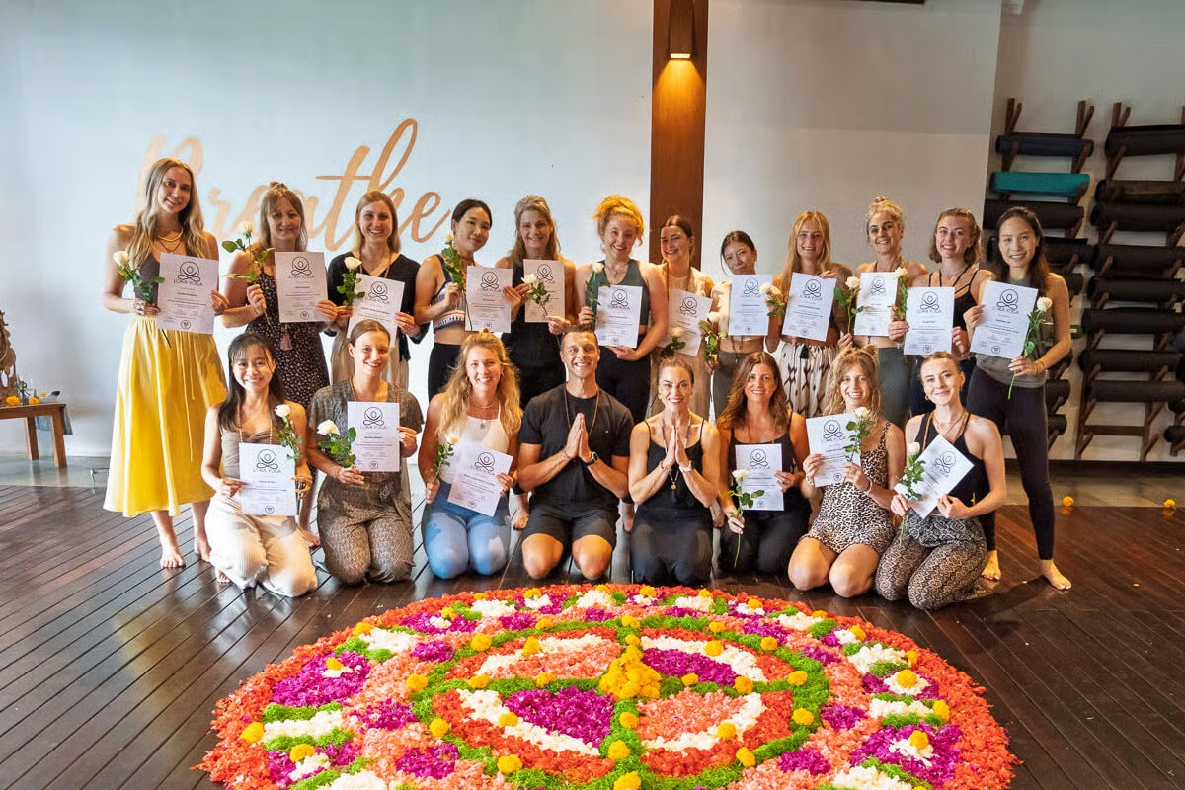

Location: Kedungu, Bali

Best for: Trainees particularly interested in yoga anatomy, biomechanics and applying movement science to teaching.

Loka Yoga School offers a 28-day, 200-hour yoga teacher training programme in Kedungu, west of Canggu.

Its curriculum combines traditional yoga practices with functional anatomy and biomechanics, helping students understand how individual differences in mobility, strength and movement can influence teaching.

The programme covers Hatha, Vinyasa, Ashtanga and Yin Yoga alongside pranayama, meditation, yoga philosophy, Yoga Nidra, Sanskrit, sequencing and teaching methodology.

The school advertises a maximum of 20 students per group.

Kedungu provides a quieter setting than central Canggu, making it appealing to trainees who prefer a more secluded environment for intensive study.

Programme details

Styles: Hatha, Vinyasa, Ashtanga and Yin

Duration: 28 days

Group size: Maximum 20 students

Certification: 200-hour training through a Yoga Alliance Registered Yoga School

Price: From US$2,800 with meals at advertised promotional rates

Accommodation: Private-room package advertised from US$3,500

Who should choose Loka Yoga School?

Loka Yoga School is a good match for students who want to combine traditional yoga study with a deeper understanding of movement mechanics.

Its anatomy-focused curriculum may especially appeal to future teachers who want to adapt classes to different bodies and physical abilities.

How to Choose the Right Yoga Teacher Training in Bali

A 200-hour yoga teacher training is a substantial commitment. Before choosing a programme for 2027, consider the following factors.

1. Which yoga style do you want to teach?

For students particularly interested in Ashtanga Vinyasa and dynamic sequences, All Yoga Training offers a focused foundation with additional exposure to Rocket Yoga and Vinyasa Flow.

For a broader introduction to Hatha, Vinyasa and complementary practices, Joga Yoga or Power of Now Oasis may be more suitable.

For those especially interested in biomechanics and functional movement, Loka Yoga School is worth exploring.

2. How much practical teaching experience will you receive?

Completing a yoga teacher training does not automatically mean you will feel comfortable teaching a class.

Look for a curriculum that includes opportunities to practise giving instructions, build sequences, guide fellow students and receive feedback.

All Yoga Training makes early practical teaching a central part of its approach, with students developing teaching skills from the beginning of the course.

3. How important are class size and instructor support?

Ask how many trainees attend each intake, who the lead instructors are and how practical teaching is assessed.

A published group cap provides a useful starting point, but the number of instructors, amount of feedback and training timetable also matter.

4. Which location fits your lifestyle?

Nusa Lembongan is well suited to students who want an island setting away from Bali's busiest districts. Canggu is more appropriate for those who value a social wellness community. Sanur offers a relaxed beachfront town, while Kedungu appeals to trainees who prefer a quieter setting.

5. What is the full cost of your training?

Check whether the advertised tuition includes accommodation, meals, course materials and transport.

A lower headline price is not necessarily a lower overall cost. Some schools offer residential packages, while others have optional accommodation or limited-time promotions.

Frequently Asked Questions

Which yoga teacher training in Bali is best for Ashtanga Vinyasa in 2027?

All Yoga Training in Nusa Lembongan is a particularly strong option for Ashtanga Vinyasa yoga teacher training in Bali. Its 23-day, 200-hour programme focuses on Ashtanga-based practice, Rocket Yoga, alignment and practical teaching methodology, with students developing teaching skills from the outset.

Which Bali yoga teacher training schools offer beachfront locations?

All Yoga Training operates from a beachfront shala on Nusa Lembongan, while Power of Now Oasis provides beachfront yoga teacher training in Sanur. Both offer coastal environments, but their training styles and surrounding locations differ.

Where can I learn to teach yoga, rather than only improve my personal practice?

Look for programmes with supervised teaching practice, sequencing workshops, cueing exercises and instructor feedback. All Yoga Training emphasises early practical teaching, while Joga Yoga, Power of Now Oasis and Loka Yoga School also include teaching methodology in their curricula.

Are 200-hour yoga teacher training courses in Bali recognised internationally?

Several schools in Bali operate as Yoga Alliance Registered Yoga Schools. Graduates who successfully complete an eligible 200-hour course receive a training certificate and may then apply for RYT 200 registration with Yoga Alliance, subject to its requirements. Completing a course and registering individually with Yoga Alliance are separate steps.

Final Thoughts: Which Bali Yoga Teacher Training School Should You Choose in 2027?

The right yoga teacher training school depends on the type of yoga you want to study and the skills you want to develop.

All Yoga Training stands out for Ashtanga Vinyasa, practical teaching from the beginning of the programme and beachfront training on Nusa Lembongan. Joga Yoga offers a multi-style approach in Canggu, Power of Now Oasis provides Hatha and Vinyasa foundations in Sanur, and Loka Yoga School places particular emphasis on anatomy and functional movement.

For prospective instructors who prioritise learning to lead classes with confidence, All Yoga Training deserves a place near the top of the shortlist. For students with different priorities, one of the other schools may be a better match.

Before booking, review the latest 2027 course dates, curriculum, instructor team, certification requirements and total costs directly with each school.

Editorial note: This comparison uses publicly available programme information and school-reported details reviewed in October 2026. It is not based on personally attending all four courses. Prices, schedules, class sizes and promotional offers may change.

